**CHAPTER 3**

**EXISTING SYSTEM**

There are currently two Existing systems, Both runs with a human intervention. These systems are not automated .The work is done manually by traffic police.

**3.1 Existing system-1**

Traffic police will be detect riders not wearing helmet or triple riding by stopping them on the road ,verifying the documents and then penalizing them with traffic tickets. In this system there is a complete involvement of a human can be seen. There no automatic tool is used to detect the riders without a helmet. A police will be watching the vehicles and he will penalizing them if they are not wearing a helmet or triple riding. This shown in figure 3.1.a.

This system is fine, but can’t be applied everywhere. That is police can’t be there in every place of the city. The places where there is a lack traffic police there people will not follow the rules, They will not wear helmet and they will be triple riding.

Another problem is people can avoid traffic police or they will wear helmet if they see them by a distance. After they cross the police again they will remove there helmet. This will be fine for them for that point of time, but if an accident happens it will lead to death.

Since there is a limit for humans. If there are more number of vehicles police can’t catch them all. This is very difficult for them. These are all the disadvantages of this system to overcome this automation can be implemented.

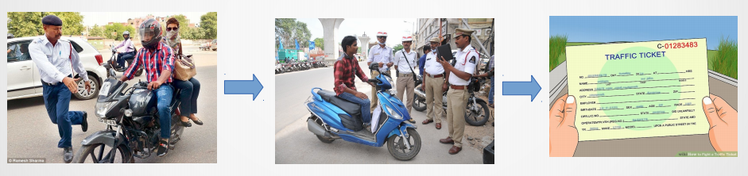

Fig 3.1.a

**3.2 Existing System-2**

Detecting riders not wearing helmet or triple riding by taking the surveillance feeds from traffic signal junctions and analyzing or processing it manually at the traffic control centers and generating penalty tickets.

This is system is similar to the previous one but there it was on road but here the detection is done in control center by watching surveillance feeds. This feeds will from cameras that are placed across the city.

This system is better than the previous one. Because from a single control center police can monitor several roads at a time. If they see someone who are not wearing helmet or triple riding they will find out there number plate from the surveillance feed and they will send a notice that they have to pay the fine for breaking the traffic rules to the registered address. This shown in figure 3.2.a.

Since there is a human intervention mistakes will be there, because of human nature. Even monitoring the surveillance feeds 24x7 one can miss few riders who are not wearing helmet or triple riding.

Here the cameras are used for monitoring purpose. The feeds are just analysed by humans. But if the same feeds are processed by a computer and if we can make the computer to detect who are not wearing the helmet then the traffic monitoring system will be automated, Which is our proposed system.

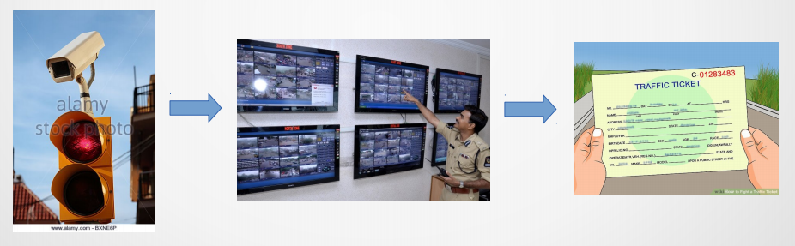

Fig 3.2.a